Chapter 4 – Humidity

**Saturation** – No more water vapor can evaporate unless one condenses; the air is completely full of water vapor.

**RH** – The amount of water vapor in the air compared to that required for saturation.

$$RH= \frac{Actual Vapor Pressure}{Saturation Vapor Pressure}x 100$$

**Pressure Gradient Force** – A horizontal difference in temperature creates a horizontal difference in pressure. This establishes a force, called the pressure gradient force that always makes the air move from higher pressure to lower pressure.

$$Pressure Gradient Force= {∆ Pressure}/{Distance}$$

**Coriolis Force** – Causes wind to deflect due to the earth’s rotation.

**Northern Hemisphere Winds Direction:**

Clockwise and outward from center of highs

Counterclockwise and inward towards the center of lows.

**Southern Hemisphere Wind Direction:**

Counterclockwise and outward from the center of the highs.

Clockwise and inward from the center of the lows.

# Clouds

**Cumulus Cloud** – Puffy cotton ball, associated with fair weather

**Cirrus Cloud** – High cloud composed of ice, wispy, looks like mare’s tail

**Stratus Cloud** – Stratified, gray, low layer of cloud taking up the entire sky. ‘Overcast’

**Cumulonimbus Cloud** – Vertically developed cloud that can produce all types of precipitation, including hail.

**Cirroform Clouds** – Thin clouds of ice promote a net warming.

**Low Stratified Clouds** – Promote net cooling. Overall, clouds have a net cooling effect presently. Clouds reflect radiation back to space, which cools the earth and emit infrared radiation to earth, which warms the earth, positive and negative feedback.

Chapter 14 – Thunderstorms & Tornadoes

**Pre-frontal Squall-line Thunderstorms** – In middle latitudes can form in advance of a cold front and have huge thunderstorms along a long length. May form ahead of an advancing cold front as the upper-air flow develops waves downwind from the cold front.

# Tornadoes

**Tornado** – Rapidly rotating column of air that blows around a small area of intense low pressure with a circulation that reaches the ground. Some scientists think that tornadoes are not linked to climate change. Better storm spotters lead to more news about tornadoes, better records.

**Funnel Cloud** – Tornado beginning to form but has not reached the ground. 30% of funnel clouds become tornadoes.

**Tornado Watch** – Tornado is likely to form in the next few hours. Often there are trained volunteer spotters who look for tornados.

**Tornado Warning** – Tornado has been spotted, visually or on radar screen.

**Fujita Scale** – Based upon the wind speed and consequent damage of storm. EF0 weakest, EF5 strongest. 1-2 EF5s occur annually in the US.

**Tornado Outbreak** – When 6 or more tornadoes occur over a particular region.

**Super Outbreak –** Many tornadoes in a short period of time.

# Supercell Tornado Formation

**Mesocyclone** - Rising, spinning air inside a thunderstorm. Lowers pressure in the mid-level of the TS. It can be 5-10km across. Precipitation can also be spun inside counterclockwise around the updraft, which can be seen by radar, although there is no precipitation in the mesocyclone.

Tornadogenesis – The formation of the tornado.

**Tornado Occurrence:**

* The US has the most tornadoes in the world, 1000 annually.
* Most occur in tornado alley, which stretches across central Texas to Nebraska
* Central Plains has warm, humid surface air and cold dry air aloft. Large supercell thunderstorms can form with strong wind shear that produces most tornadoes.
* Highest in spring, lowest in winter, because of warm, humid surface air. Most frequent in late afternoon because the air is most unstable.
* 45% of all fatalities occur in mobile homes.

|  |  |  |
| --- | --- | --- |
| **Rating** | **Winds** | **Damage** |
| EF 0 | 65-85 | Minor |
| EF 1 | 86-110 | Moderate |
| EF 2 | 111-135 | Considerable |
| EF 3 | 136-165 | Severe |
| EF 4 | 166-200 | Extreme |
| EF 5 | > 200 | Catastrophic |

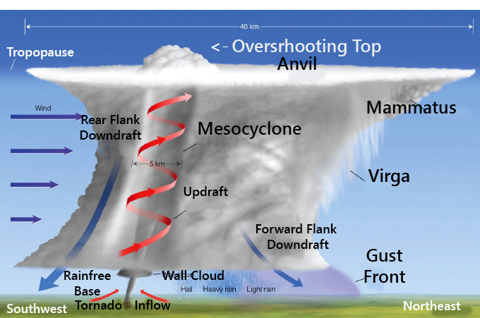 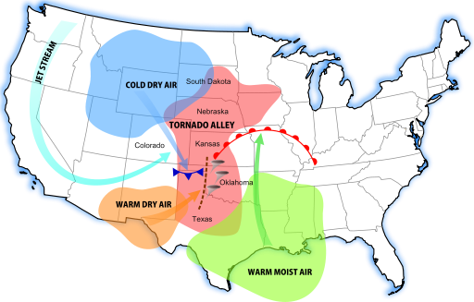

# Chapter 15 – Hurricanes

**Tropics** – Area 23.5* N and S of the equator

**Streamlines** – Sudden wind gust with heavy downpour. Instead of using isobars on maps, streamlines are used to show wind flow.

**Tropical Wave** – A weak trough of low pressure, wind traveling east to west.

**Hurricane** – Intense storm of tropical origin with winds greater than 64 knots over the north Atlantic and eastern North Pacific. Usually last a week.

**Typhoon** – Western North Pacific

**Cyclone** – India+ Australia

**Eye** – Area of broken clouds at the center of a hurricane. Low pressure, winds, & precipitation.

**Eye Wall** – Ring of intense thunderstorms around storm’s center. Heaviest precipitation and strongest winds.

**Environment for Hurricanes** – Tropical waters with light wind, 26.5 Celsius warm sea surface temperatures. Will NOT form at the equator due to no coriolis effect. Usually formed between 5-20 degrees latitude in the tropics. They lose energy over cold water or large land mass (friction) or in a region of strong vertical wind shear.

**Hurricane Stages of Development**

1. **Tropical Disturbances** – Mass of thunderstorms with slight winds
2. **Tropical Depression** (22-34kts) – Isobars close together around a ‘L’ center
3. **Tropical Storm** (35-64kts) – Isobars packed very closely together
4. **Hurricane** (> 65kts)

**North Atlantic Hurricanes** – Most hurricanes hit land in U.S. on East and Gulf Coast. Rarely do hurricanes hit the west coast since they move westward. Atlantic hurricanes will survive longer than in the pacific due to warmer water.

**Naming Hurricanes & Tropical Storms** – Storm is named when it becomes a tropical storm or hurricane. Alphabetical, alternating male and female names (1979+), great damage, cat. 3 or higher, the name is retired for 10 years (Katrina + Camille)

**Storm Surge** – A major source of damage from hurricanes, where the rotation of the storm pushes the water onto land and causes flooding. When a storm surge moves in at high tide, it can destroy a wide swath of coastal lowlands, as it did in hurricane sandy.

**Saffir-Simpson Scale** – 1 weakest, 5 strongest. Major hurricanes are cat 3 or higher. Typhoons that are >150MPH are super typhoon. Prior to 2010 measured central pressure + storm surge, now measures wind speed + damage.

**Hurricane Watch** – 24-48 hours prior to landfall

**Hurricane Warning** – Issued when forecasted that it will hit, along with a % probability that the center will pass within 105km of a community.

**Hurricane Katrina** – Costliest hurricane in U.S. history, cat 3-5 with winds of 175 mph, over 1,500 deaths.

**Hurricane Sandy** – 3rd costliest hurricane in U.S. history, storm surge caused the most damage.

**Tropical Cyclone Nargis (2008)** – Hit Myanmar, 16 foot storm surge in-land at least 50km. 140,000 deaths.

**Tropical Cyclone Yasi (2011)** – Hit northern Australia with massive flooding’s, winds over 172mph.

**Super Typhoon Nalgae (2011)** – Hit Philippines > 150mph

**Great Hurricane of 1780** – Caribbean, 27,000 deaths

Chapter 16 – Climate Change

**Ice Age** – 18,000 years ago the earth was covered with huge sheets of ice (Glaciers), covering much of North America + Europe. Over the last 2.5 million years, it is thought that the glaciers advanced and retreated repeatedly, leaving geologic evidence in rocks as well as evidence in ice cores.

**Techniques for Reconstructing Past Climates** –

* Geographical evidence from glaciers (striations in rocks can show glaciers retreating, as they scrape the rocks)
* Fossil pollen from ancient plants
* Ice cores
* Study of shells
* Historic documents containing details about climate and weather.
* Study of ocean sediments with shells of organisms that live in narrow temperature ranges. Oxygen isotopes - Oxygen isotopes- 16O vs. 18O (18O is heavier, with 2 more neutrons). 16O is more abundant than 18O. 16O evaporates more readily from the ocean than 18O, and becomes locked in glaciers. Shells have higher 18O than 16O concentrations in colder climates.

**Ice Cores** – Colder air has higher concentration of 16O in ice cores. Bubbles of air can have carbon dioxide, methane, and other greenhouse gases that can show the atmosphere composition. Sulfuric acid can show volcanic eruptions.

**Dendrochronology** – Study of tree rings. Changes in thickness of ring can show climatic changes. Frost rings in cold periods. Stresses from temperature and moisture in density of growth rings.

**Pleistocene Epoch** – The most recent ice age began 2.5 million years ago.

**Modern Temperatures** – 20th century was the largest increase in temperature of any century during the past 1,000 years. 0.6*C raise in global temperature during the 20th century (1*F), called global warming. In the 21st century, may be around 2*C (3.6*F). For comparison, global temperatures have not varied more than 2*C over the past 10,000 years.

**External Reasons for Climate Change** – Change in incoming radiation, change in composition of the atmosphere, & change in the earth’s surface.

**Internal Reasons for Climate Change –** Ocean and air circulation patterns that can redistribute energy.

**Positive Feedback Mechanisms** – An increase in heating is reinforced by other processes.

**Water Vapor-Greenhouse Gas Feedback (+)** – As earth heats, more water vapor evaporates, and water is a greenhouse gas, which leads to more warming, which leads to more evaporation.

**Runaway Greenhouse Effect (+)** - If left undisturbed, all water would evaporate.

**Snow-Albedo Feedback (+)** – As snow and ice melt in a warming planet, the albedo of the surface is reduced. This allows more solar energy to reach the surface, which heats it up and raises the temperature, melting more ice, which reduces albedo more and heats up more. In cooling planet there is the opposite, as snow and ice increases and reflects more heat back, it cools more, and makes more ice, which has a higher albedo and cools more. In Polar Regions snow reflects much of the sun’s energy back to space. If the air temp were to gradually increase, some of the snow would melt, less sunlight would be reflected, and more sunlight would reach the ground, warming it more quickly.

**Negative Feedback Mechanisms** – Weaken the interactions among variables rather than reinforce them.

**Infrared Radiation (-)** – Warming planet emits more infrared radiation, cooling the surface.

**Chemical Weathering CO2 Feedback (-)** – Carbon dioxide is removed from the atmosphere as silicate minerals decompose in presence of moisture. Generally happens on warmer planets because of more evaporation/precipitation.

**Milankovitch Theory** – Variations in the earth’s orbit influence climate change, including:

* **Eccentricity** – Changes in the shape of the earth’s orbit around the sun.
* **Precession** – The earth’s axis of rotation
* **Obliquity** – Changes in the tilt of the earth’s axis.

**Volcanic Eruptions** – Fine particles of ash and dust are ejected into the atmosphere. The greatest impact from volcanoes is thought to be from sulfur gas, which combines with water vapor making visible sulfuric acid particles, forming a thick haze that reflects heat and causes the earth’s surface temperature to cool for 2-3 years.

**Greenhouse Gases** – The increase of CO2, CH4, N2O, CFCs, increasing warming effect.

**CO2** – Has been increasing in the atmosphere from the burning of fossil fuels like coal and oil as well as deforestation which CO2 stores in leaves, when they are burned, CO2 goes into the atmosphere.

**CH4 / Methane** – Increases from sources such as waste in landfills, wetlands, and natural gas.

**Coal** – Formed from the dead remains of trees, ferns, and other plants that lived 300-400 million years ago. Burning releases the carbon from the plants as CO2.

**Oil and Natural Gas** – Formed from prehistoric organisms that lived in water and were buried under sediment. Heat, pressure, and bacteria combined and compressed to make oil and natural gas.

**Desertification** – Changes in albedo where overgrazing of grasslands turns it into deserts. Millions of acres annually are converted to desert, making land useless. Causes are overgrazing, over cultivation, poor irrigation practices, and deforestation.   
**Radiative Equilibrium** – When rate of incoming solar energy balances rate of outgoing infrared energy. Carbon dioxide and other greenhouse gases disrupt radiative equilibrium, forming an increase in temperature.

**Radiative Forcing Agents** – Increasing concentrations of GHG can disrupt equilibrium.

**Kyoto Protocol** – International agreement targeting reduction of emissions primarily by developed countries. Committed to reducing GHG emissions.